Java Generics.
Generics allows us to take classes , interfaces, methods that takes types as parameters.
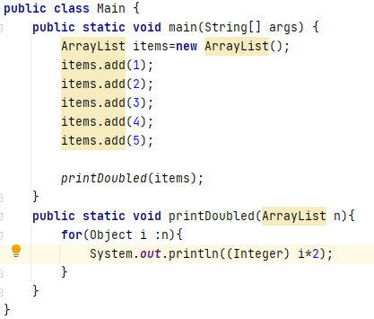

The problem above there is no type checking, which can be inconvienet.
When we actually provide type parameter to a generic type, it is called as parameterized type.
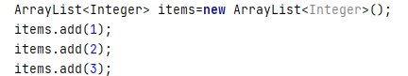

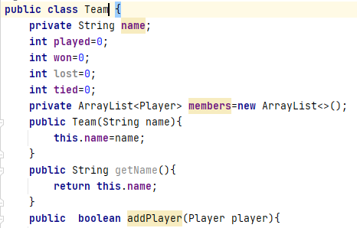
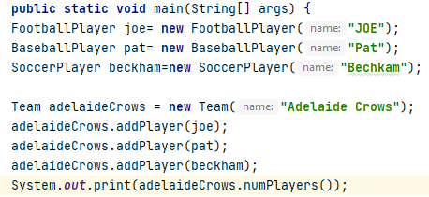

Above the problem we want only to add football players to a football team.
So we would create 3 classes, Football team, Baseball team, Soccer team
But in that case the code will be largely identical.
We can obvioulsy extend Team class, but in that we need to have functionality unique to each team type in the code as well.
So common method playGame, recordScore etc would be in the base team class.
Fortunately jave got generics and it enables us to specify a type when we are creating our class.
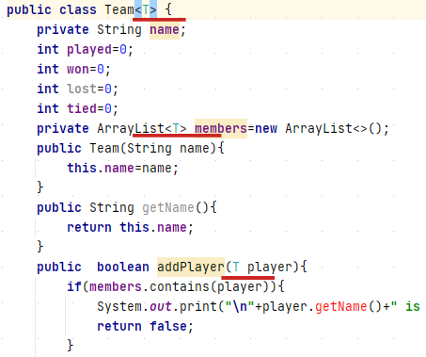

We are changing the type, so its going to work for any type of player. So when we instantiating a class, the T will be replaced with the class we passed.

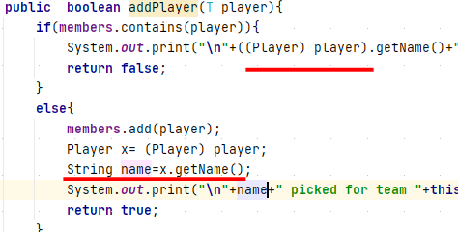
Two ways to solve issues:

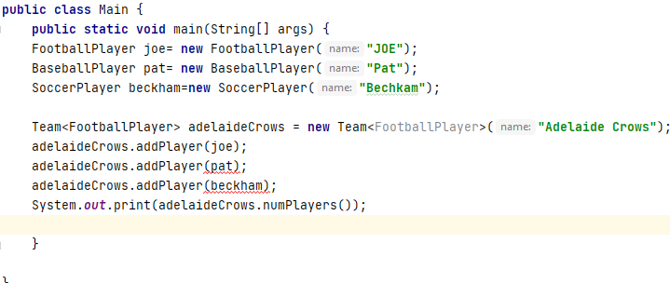
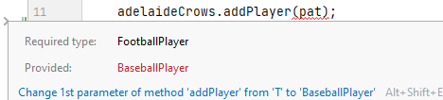

We can also restrict more: this is called as bounded type parameters
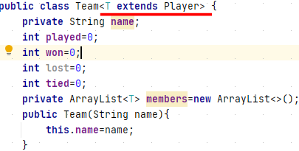

An argument pass as type parameter can either be a class or interface.
Interface can themselves specify type parameters.
We use a Single bound when we specify Team type parameter, restricting teams to be created for objects that’ll inherit from player class or subclass of player.
Java does allow multiple bounds, so u can have class T extends Player and coach and manager.
For e.g to allow multiple instances of player,coach or manager to be added to the team.
But with that in mind, the normal inheritance implements rules still apply.
But u can extends from only single class and multiple instances.
If u specify multiple bounds then the class must be listed first otherwise Java’s gonna raise an error when you try to actually compile it.
IOW class first and then interfaces.
2.
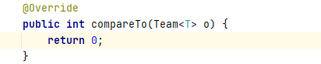

If u got a list of objects that implements comparable such as ArrayList of Team
what you can do is you can quickly sort the list using the static sort method of the collection class.
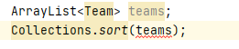

The whole thing is gonna be sorted using the compareTo() func that we wrote for the Team class.
E.g
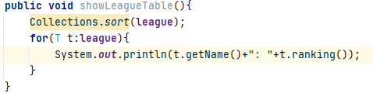

Generic Challenge.
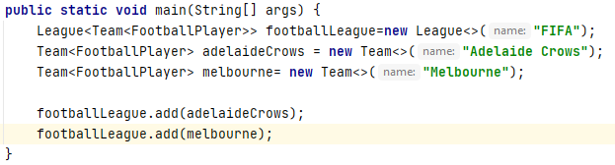
You can also

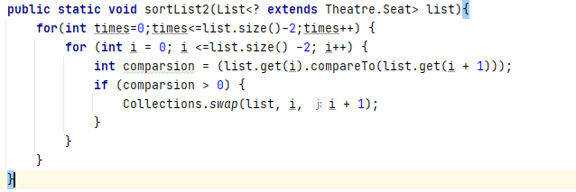

Naming conventions,packages, scope, static and final keywords.
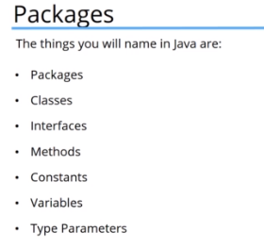

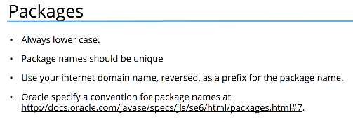

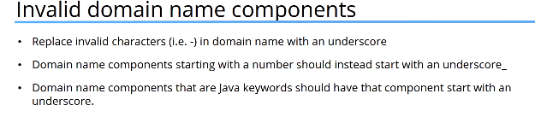
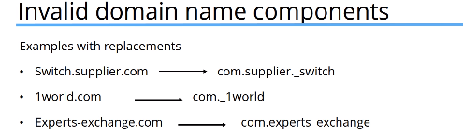

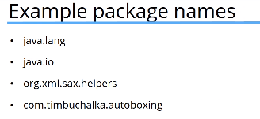

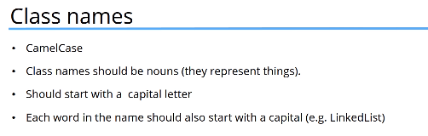

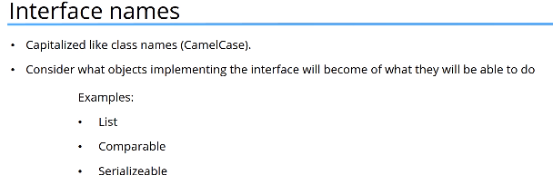
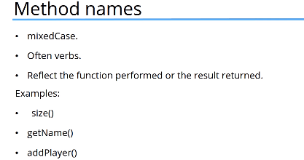

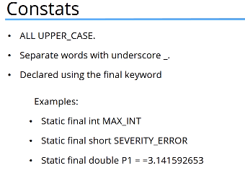

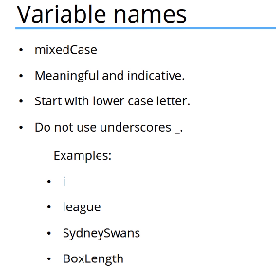

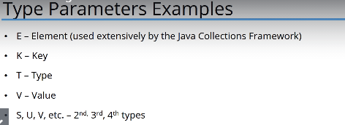

Packages
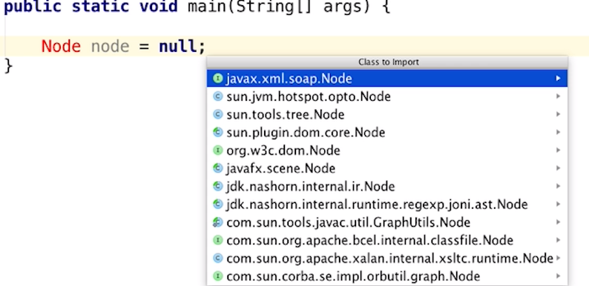

Package is a way of grouping related classes and interfaces together, so the actual mechanism provides a way to manage the name space of object types and it also extends access protection beyond the traditional access, modifier you see before public, protected, private, etc.
Another way of doing
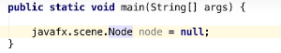

If you using 2 different Node class, then one of them has to be use like Above.
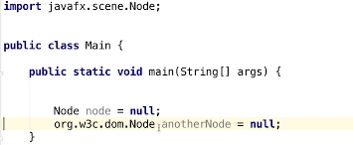

If u use full Name: it would be clear which one you meant.
Why you wanna use Packages:
1) To easily determine Classes are related to one another.
2) Easy to find classes and interfaces that can provide the functions provided by the package.

3) Because the package creates a new namespace, class and interface name conflicts are avoided.
4) Classes within the package can have unrestricted access to one another while still restricting access for classes outside the package.
5) Major doubt solved
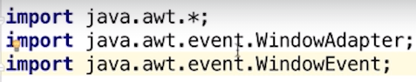

java.awt.* doesnt cover java.awt.event.WindowAdapter.
These are seperate packages.
Even though its nested.
Packages part 3:
Creating Java Archive (like a zip file)
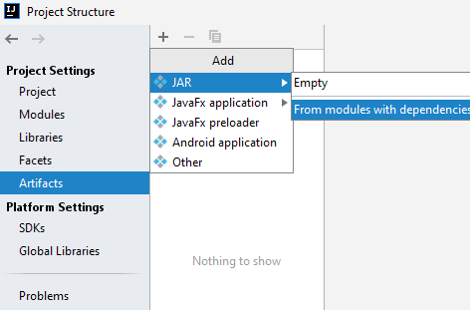


If u want the jar file to be executable specify the Main class.
Click on ok and see the output directory. Thats it.

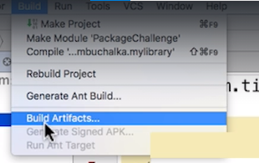
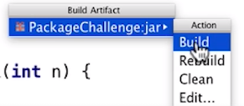

Step 2: Add jar files to projects.
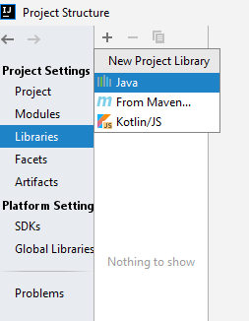

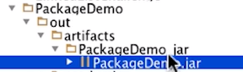

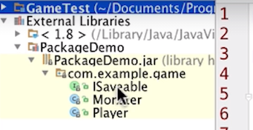

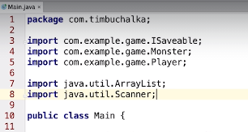
Here , we are able to execute the code.
Package Challenge.
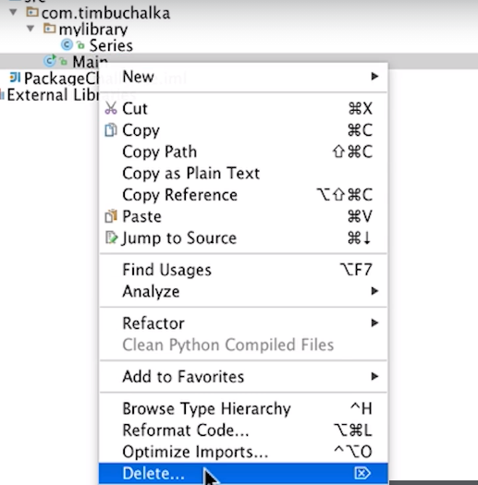

Delete the Main file after use and create ur jar file.

Scope: You already know
Access Modifiers:
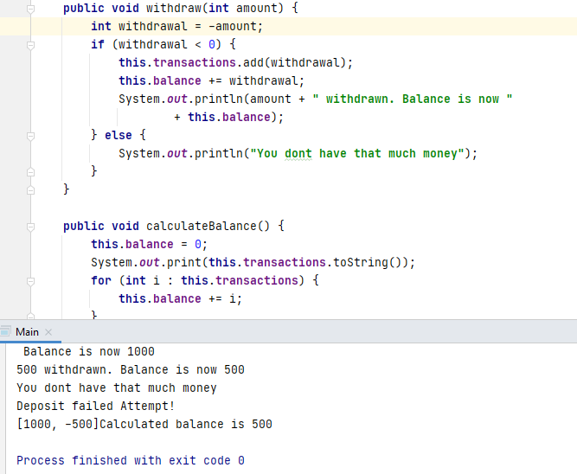
THIS IS Pretty smart.
So access Control is granted by the top level or at the member level. So
at the top level you can make ur classes or interfaces public or package private.
You cant define a private class at the top level.
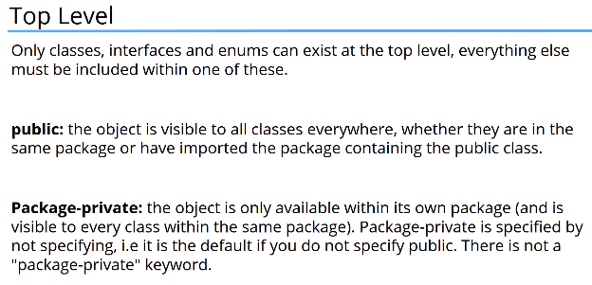
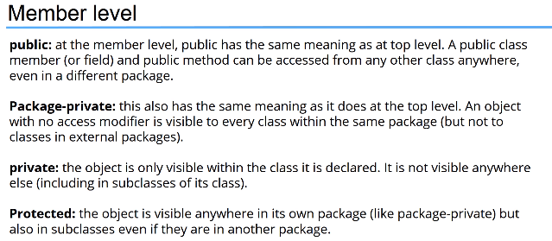

Link to understand: Access Modifiers
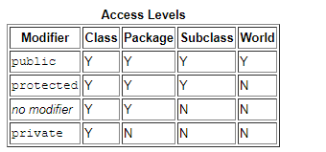

The second column indicates whether classes in the same package as the class (regardless of their parentage) have access to the member. The third column indicates whether subclasses of the class declared outside this package have access to the member. The fourth column indicates whether all classes have access to the member.
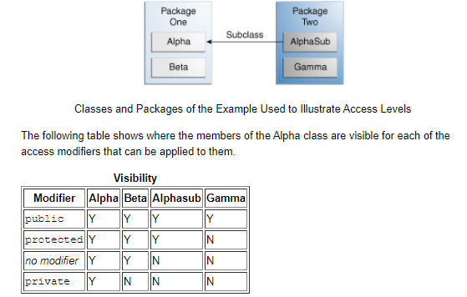
Above Alpha is a subclass of AlphaSub.
Notes:
In protected you can extend, if u extending then u obvioulsy have access to member variables.
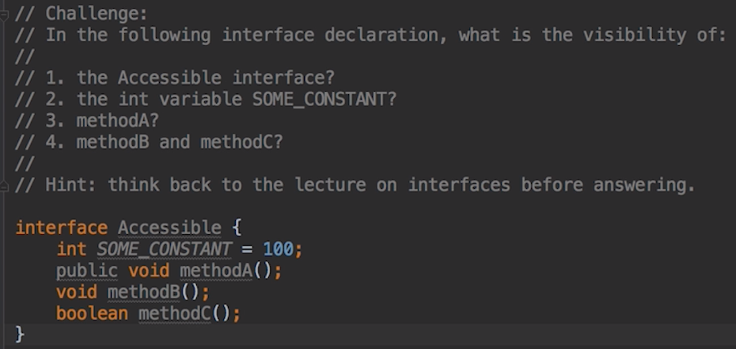
1.package private, 2.public static final, 3.public ,4. public, 5. public
Note: You can make the methods package-private by making the interface here itself package private (duh!)

Static statement : static statement
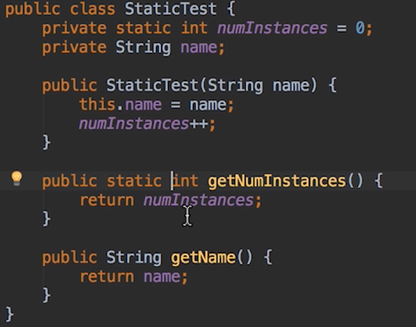

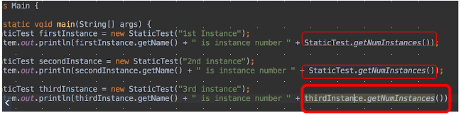
Static member/fields belongs to the class and not the instance of the class.
At time 12 bookmark, likewise psvm, a static method can access nonstatic fields and methods in another class because it creates an instance of a class in order to do so.
Final statement: final statement
-Generally use to define constant values, so strictly sepaking final fields are not actually constants because they can be modified but only once, and any modification must be performed before the class constructor finishes.
- That means we can assign final field value when we first declare it or in the constructor.
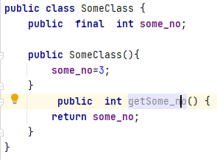
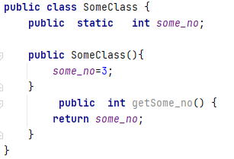

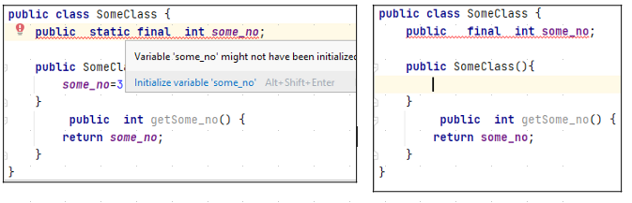
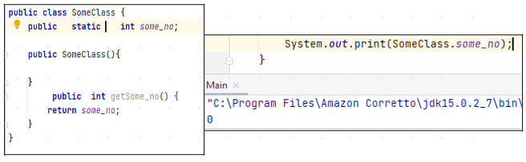

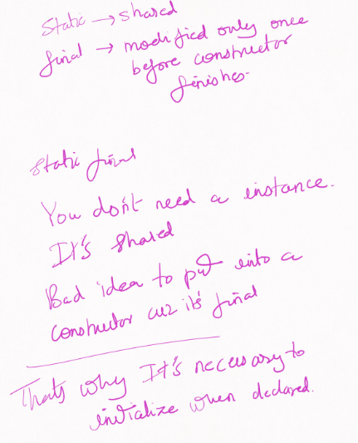

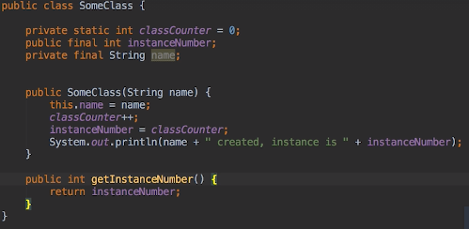

Here instanceNumber is consider constant after we assign its value.
Thats the reason why its not uppercase.
PSF variable is a value which is not gonna change and it doesnt make sense to store a copy of that for every class instance.
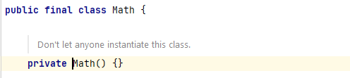

The constructor is marked private to prevent instance to be created.
The reason that is done in the Math class cuz all math class methods are static.
To enforce this the creator make the constructor private.
You’ll think I can go around that by creating a subclass which you instantiate, and the creator have thoughted that pretty well by declaring the Math class final .
Which prevents the class to have any subclass.
Same for method declared as final . You dont want method over-riding.

Video : Final part 2 and static initializer
Opposite to our normal instance constructor we have static initialization block.
In this that block is executed once the class is first loaded into the project.
Static final variable must be initialized by the time or static initialization blocks terminate. So in the same way that we can set the value of final field in the constructor. We can also assign the value of a static final variable in the static initialization block.
Static initialization block is an Advanced feature and theres rarely a case you would use them.
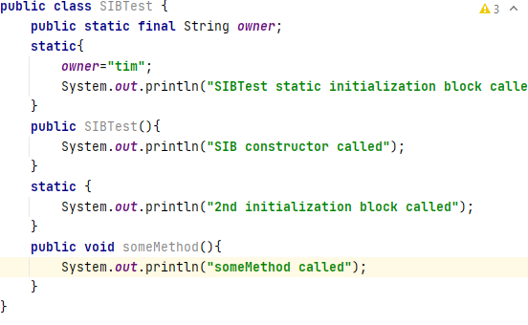
You can have multiple static initialization block and they are called in the order they are declared in the class.
There is a Warning, the second initialization block should be after first initialization block to avoid confusion. It doesnt matter but still.
